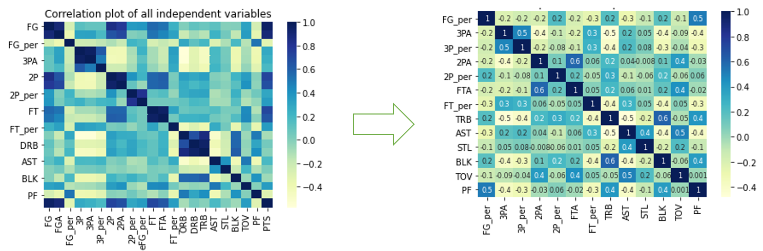

Dropped:

* FG, FGA
* 2P,3P, PTS
* eFG_per
* FT
* ORB, DRB

|  |  |
| --- | --- |
| Variables/constant | VIF |
| Const. | 143.791152 |
| FG_per | 1.614407 |
| 3PA | 1.897377 |
| 3P_per | 1.420394 |
| 2PA | 2.081304 |
| 2P_per | 1.236864 |
| FTA | 1.837963 |
| FT_per | 1.363539 |
| TRB | 2.325915 |
| AST | 2.340412 |
| STL | 1.208616 |
| BLK | 1.785898 |
| TOV | 2.040931 |
| PF | 1.936028 |

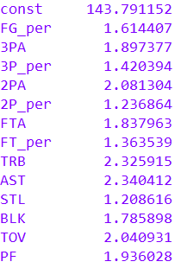

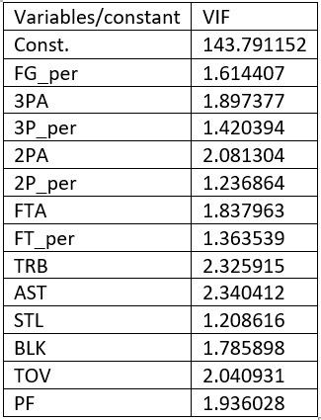

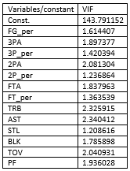

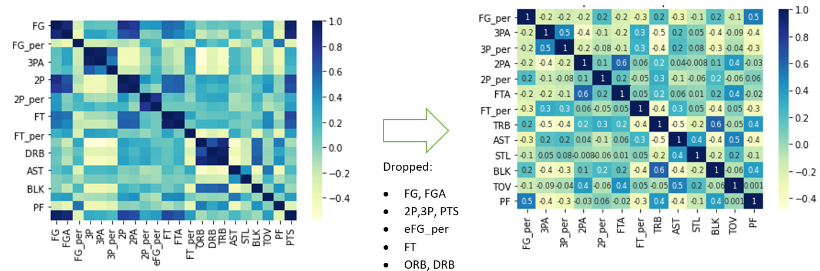

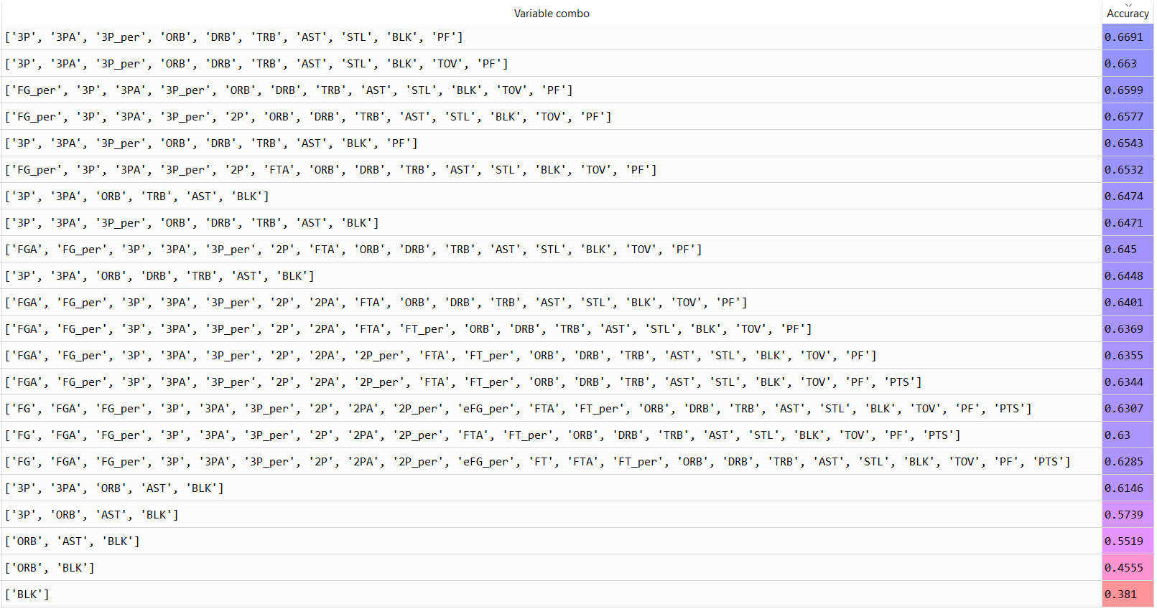

…

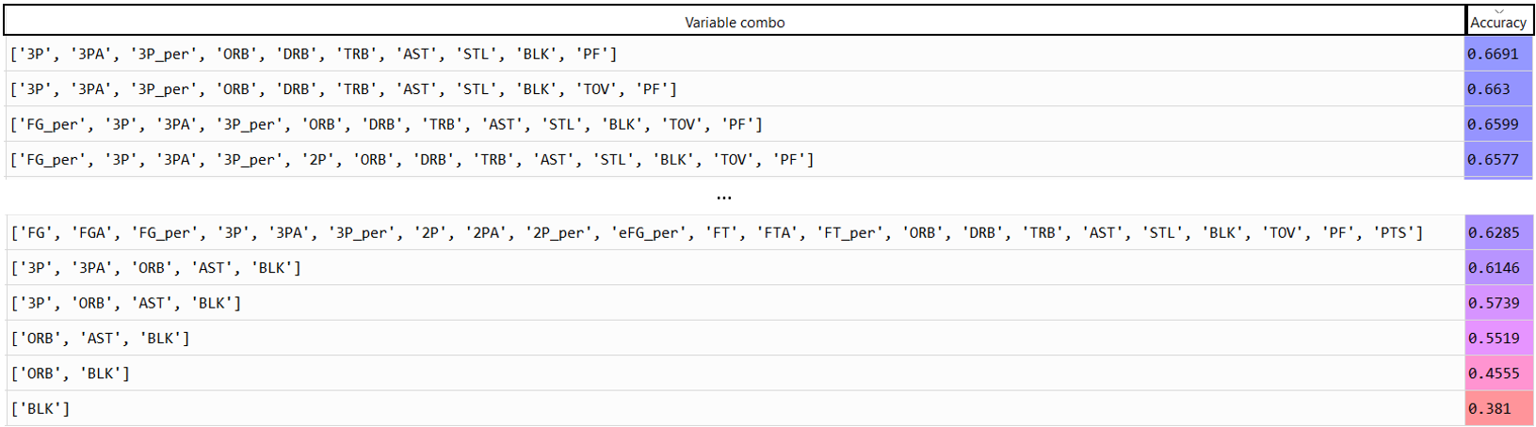

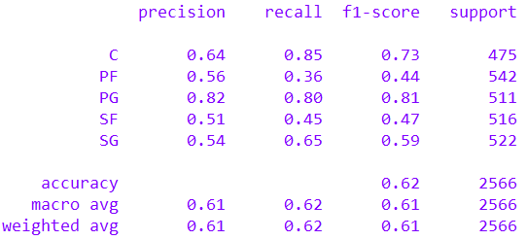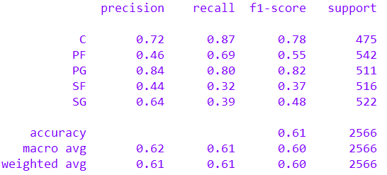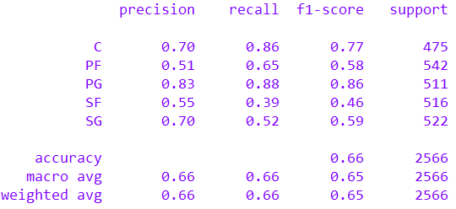

**KNN**

**Log_reg**

**GNB**



**Labels**

**Label Occurrence**

Figure 4: KNN

Figure 3: Log_reg

Figure 2: GNB

|  |  |  |  |
| --- | --- | --- | --- |
| Metric | KNN | Log_reg | GNB |
| Accuracy | 0.61 | 0.66 | 0.62 |
| Weighted Precision | 0.61 | 0.66 | 0.61 |
| Weighted Recall | 0.61 | 0.66 | 0.62 |

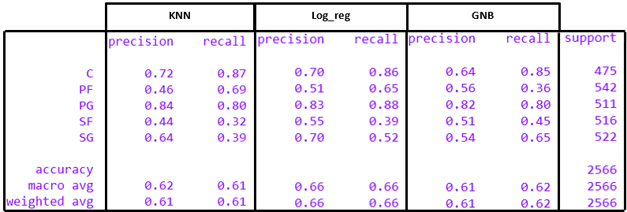



Figure 4: KNN



Figure 3: Log_reg



Figure 2: GNB

